Custom project progress/final report

COS30017 Software Development for Mobile Devices 2024

Ta Quang Tung

104222196

GitHub repo: <https://github.com/SoftDevMobDevJan2024/customapp-104222196>

Table of Contents

Overview of project 1

Weekly reports 1

Week 7 1

Week 8 1

Week 9 2

Week 10 2

Week 11 Error! Bookmark not defined.

Level 1: Design evidence 2

Level 2: App evidence 3

Level 3: Extended research evidence 6

# Overview of project

My custom project is a smart home application that allows users to create and manage smart devices in their home. It is roughly based on Google Home.

# Weekly reports

## Week 7

*As of this week, I have sketched out the screens I want to include in my app and the way they should be linked together. I am planning to use Jetpack Compose for my custom app because it is similar to React from web development, which I already know. I have not written any code for the app yet because I am still learning Compose. However, next week I will try to get the skeleton of the pages running and include more advanced UI components.*

## Week 8

*Over the past week I have learned enough Jetpack Compose to have some basic screens up and running. I have also learned Material UI to style my app. This week I have decided that my app will only focus on two types of devices (lights and air conditioners) because I don’t think I have enough time for more. The same logic for lights and ACs can be extended to other devices anyways, so having them is only a matter of copy and paste, which doesn’t showcase my learning by a lot. With that in mind, I have designed the schema for my database, which contains two tables for lights and ACs. Next week, I plan on integrating the database to my app with the Room API.*

## Week 9

*This week I have successfully integrated the Room database into my app and have been able to perform all CRUD operations. I am also trying to follow Android’s recommended architecture consisting of three layers: UI, domain (optional), and data. The UI layer is specified by Composable functions and contains ViewModels that retrieve data from repositories from the data layer. However, this approach requires writing a lot of boilerplate code that has to be copied over for each screen. Because of this, I have not been able to complete all the screens of the app. I will try to finish them by next week and also begin integrating Preferences DataStore into my app.*

## Week 10 + 11

*Over the past two weeks I have completed all the screens of my application and have successfully integrated Preferences DataStore into the app. I use this storage option to store global application settings such as dark mode preference and username. At this stage, the CRUD app is practically finished and I am in the process of catching bugs, cleaning up the code, and adding minor touch-ups to the app. I also have the idea of configuring devices to automatically turn on or off at a specific time and notifying the user using AlarmManager and Notifications, but I am not sure if I can complete this before the mini-conference given how many deadlines I have. :(*

# Level 1: Design evidence

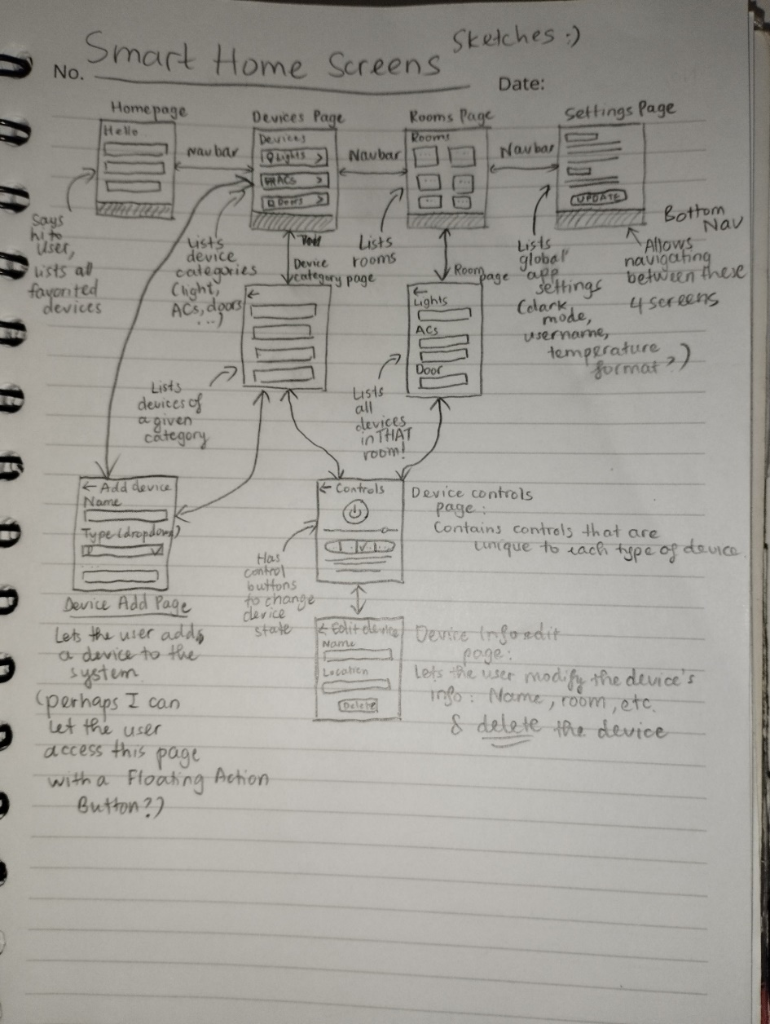

Week 7 - Sketches of screens that I plan to include in my app. I plan to have a bottom navigation bar for the user to switch between the top 4 pages. The rest should only be accessible through links and buttons on other pages.

# Level 2: App evidence

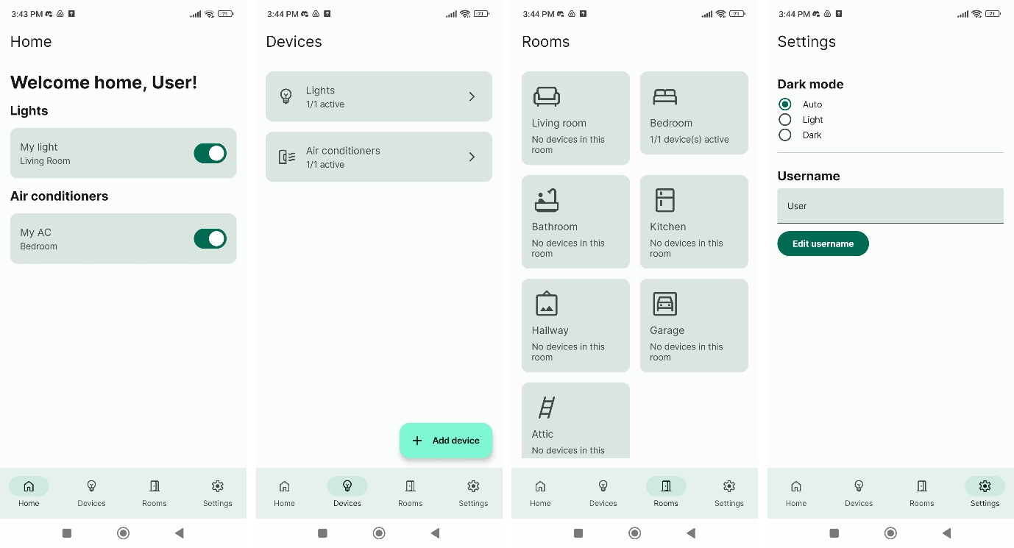

Week 8 - The four main screens I have implemented for my app, styled using Material UI. At the moment the buttons and tabs don’t do anything yet (except the bottom nav bar.)

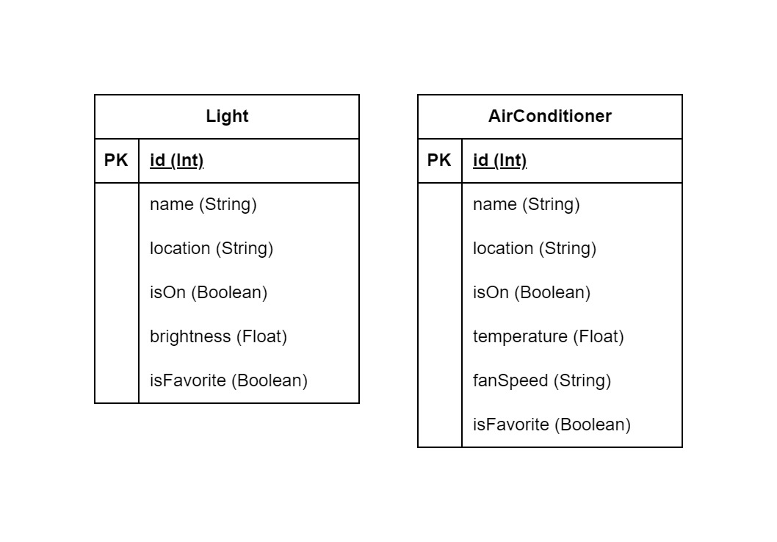

Week 8 - Schema for the database, which will be implemented next week.

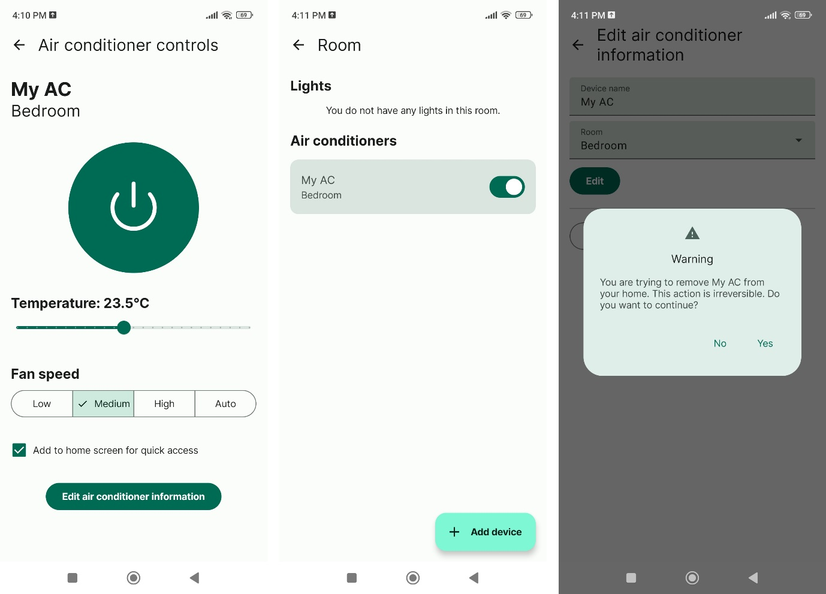

Week 9 – Additional screens implemented to support CRUD features.

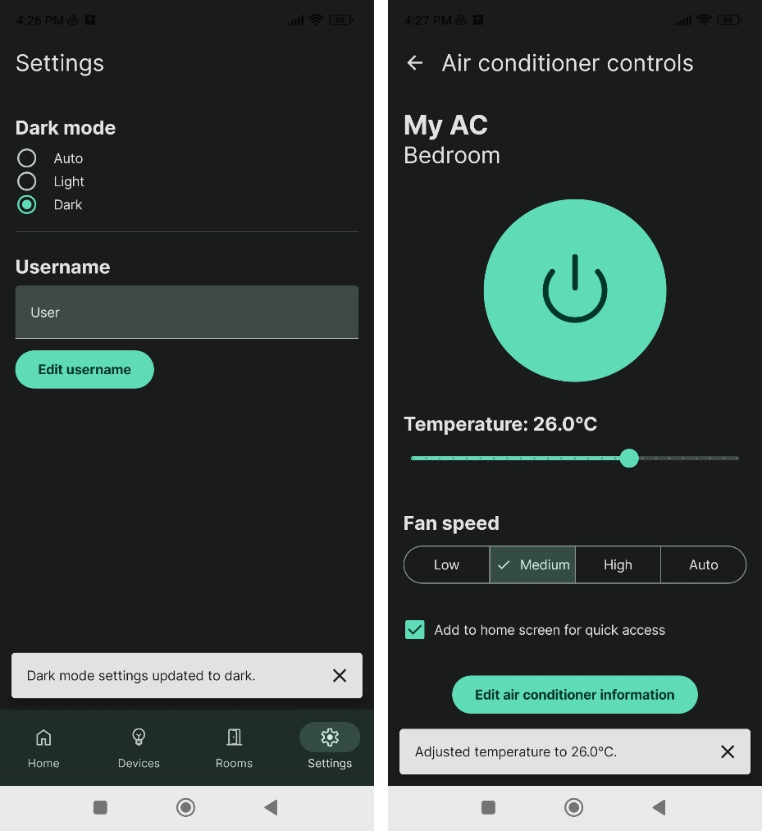

Week 11 – DataStore Preferences to update global settings, also snack bars to make the app more responsive.

# Level 3: Extended research evidence

I think I will stop at level 2.

# References